Bee Reproduction

1 The solution, pseudocode, instance of the problems, and all possible cases

* 1. 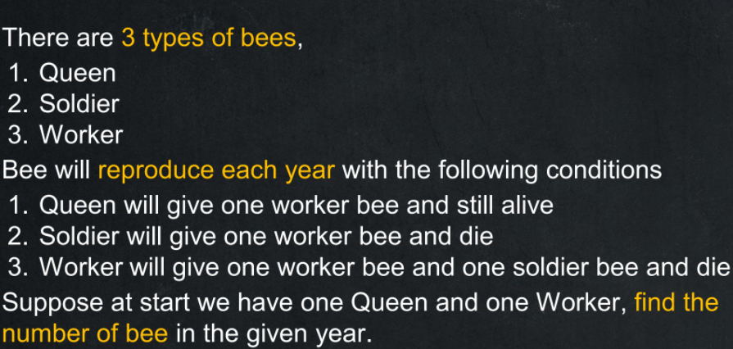The problem
  2. The solution
     1. instance of the problems

1.2.1 input and output

- input: the number of the year

- output: the number of the bee

1.2.2 condition

- in this be hive there have a 3 type of bee Q, W and S

- Q will product 1 W

- W product 1 W and 1 S and die

- S product 1 W and die

- repeat this in every year

1.2.2 The solution in all possible case

To do this kind of problem we need to find pattern of each year that bee will product thus I will use Y as a year representative like Y0 mean year 0

Initial year or year 0 has Q and W bee or 2 bees in total

Y0 = 2

And Q product 1 W then W product 1 W and 1 S so

W + W + S + Q now in first Y will have 4 bees

Y1 = 4 (WWSQ)

And process will be repeat like first year  
W product 1 W and S then die

S product 1 W then dies

Q product W

So second year will have WSWSWWQ or 7 bee in total

Y2 = 7

And third year will be WSWSWSWSWWWQ following by repeat condition

Y3 = 12

So, if we make them as an equation will be something like this

Y0 = 2

Y1 = 4

Y2 = 7 or Y2 = Y1 + Y0 + 1

Y3 = 12 or Y3 = Y2 + Y1 + 1

Thus

Yn = Yn-1 + Yn-2 + 1

And this equation (Yn = Yn-1 + Yn-2 + 1) can represent all possible case

* 1. pseudocode

Define : Read() mean function that receive input from user

Function BeeEachYear (Integer:n) -> Integer :

If n == 0 Then

Return 2

Endif

If n == 1 Then

Return 4

Endif

Return BeeEachYear(n-2) + BeeEachYear(n-1) + 1

Endfunction

Start

Let n <- Read()

Display BeeEachYear(n)

End

1. implement a code

implement with python 3.8 on visual studio code with python extension

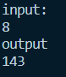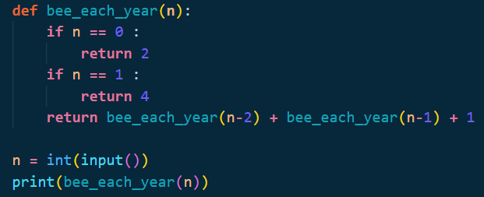Sahachan Tippimwong 622115039